1. 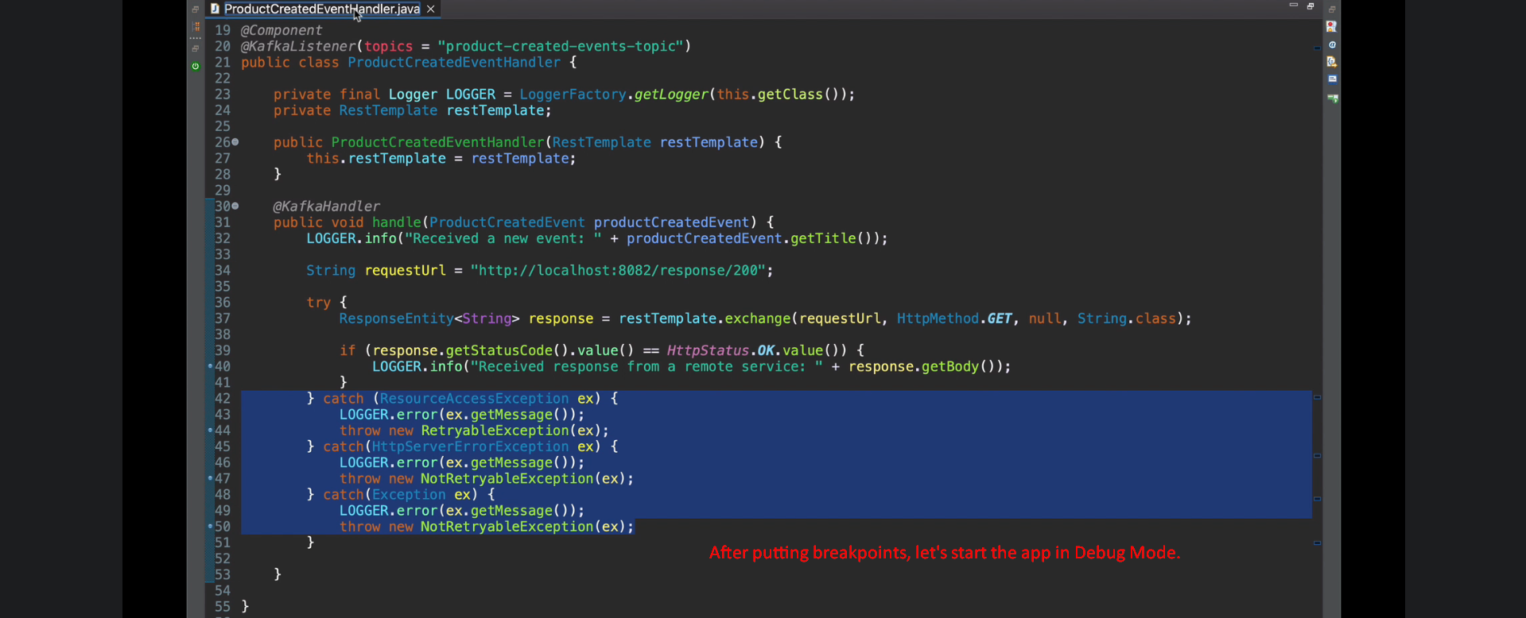
2. 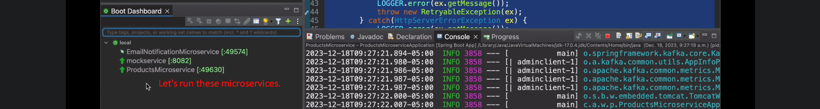
3. 
4. 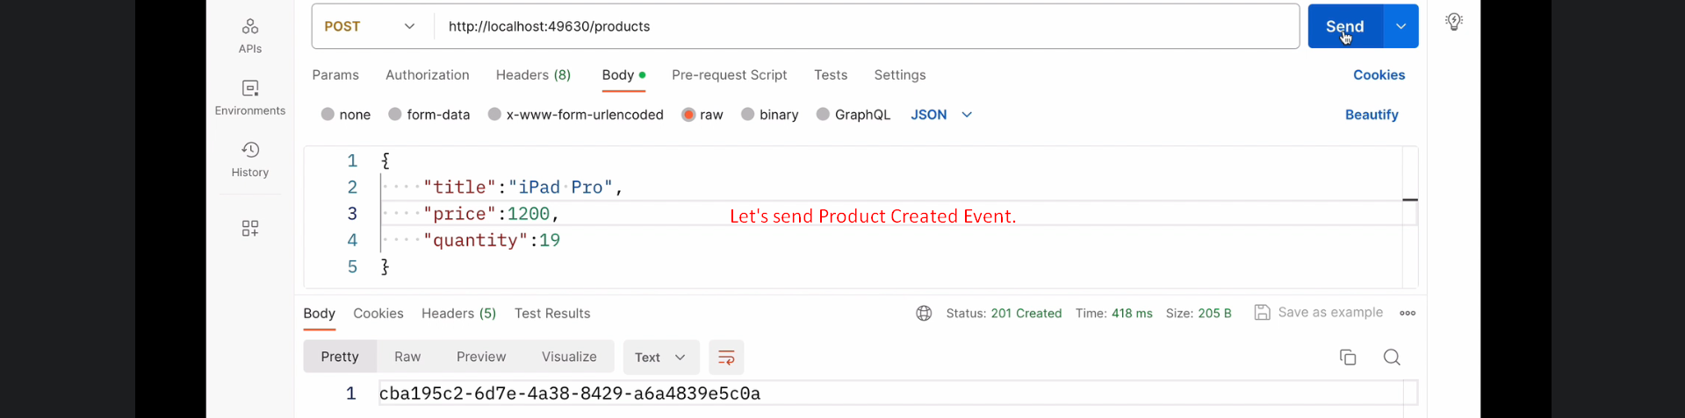
5. 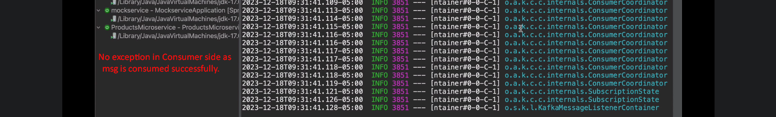
6. Let’s stop mock microservice so that we get 500 error msg in consumer app.   
     
     
   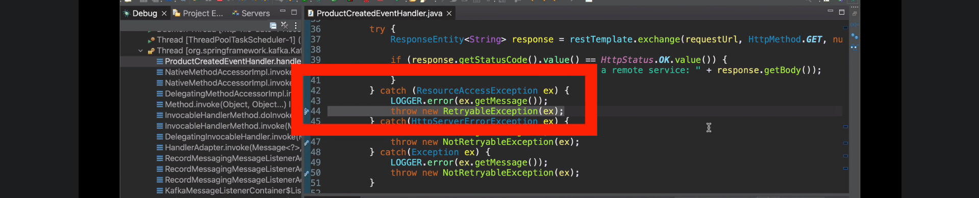  
     
   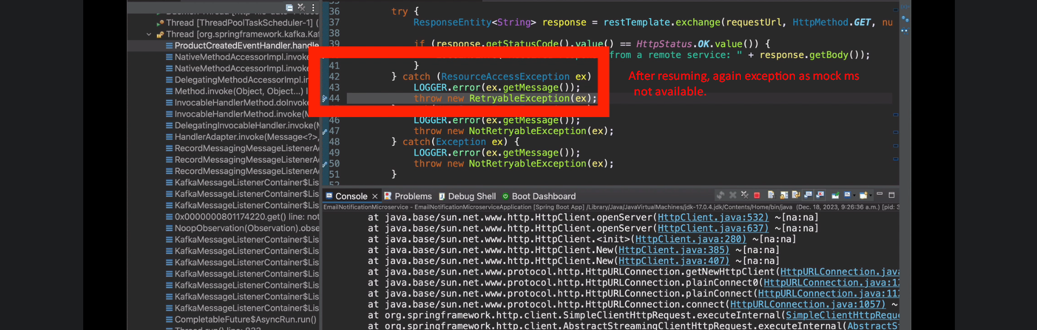
7. 